**Project Documentation**

What software Eng SE?

* state of the art of developing quality software on time and

Within budget.

* Trade-off between perfection and physical constraints
* SE has to deal with real-world issues
* State of the art!
* Community decides on best practice + life-long education

What are SDLC (software dev life cycle) & its rules?

* For project development rules & regulation need to be followed for best quality output at defined time limit
* Rules are Software Development Life Cycle – SDLC
* It‘s part of software engineering
* Six rules to be followed…

Project Rules & Regulation (SDLC) Software deve life cycle

6 RULES

1. Requirement
2. Analysis

Requirement analysis

Time requirement

Budget

How many users

**Step 1: How many user work on website**

* 1. Guest
  2. Customer ===🡺 Website

* 1. Admin ===🡺 Admin
  2. Makeup Artist ===🡺Artist

**Step 2: Define work of each user**

* 1. Guest

Website visit

Search location vise Artist

View Artist

Contact us

* 1. Customer

Website visit

Search location vise Artist

View Artist

Contact us

Signup

Login

Manage profile

Contact Makeup Artist

Logout

* 1. Admin

Login

Manage location add /upd/del

Manage Makeup Artist add /upd/del

Manage Contact us

Manage/View Customer

Manage Contact Makeup Artist add /upd/del

Logout

* 1. Makeup Artist

Login

Manage profile

Manage service

Manage album

Manage Customer Contact us

Logout

=====================================================================

**Step 3: Define panel by user**

Website: Guest / Customer

Makeup Artist panel: Employee

Admin Panel: Admin

**Step 4: Define Some Diagram**

1. **Use case Diagram**

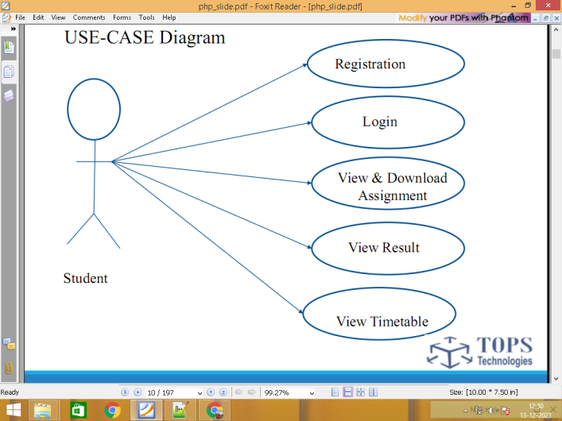

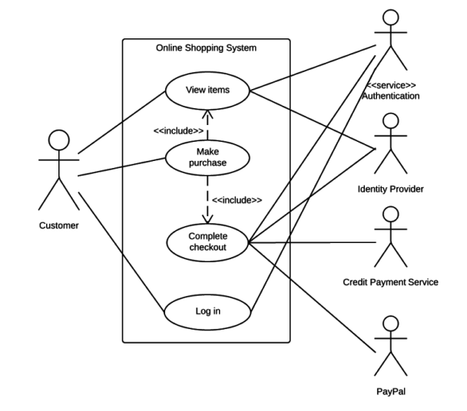

1. **DFD Data flow diagram level 0 / 1 / 2**

**0 level**

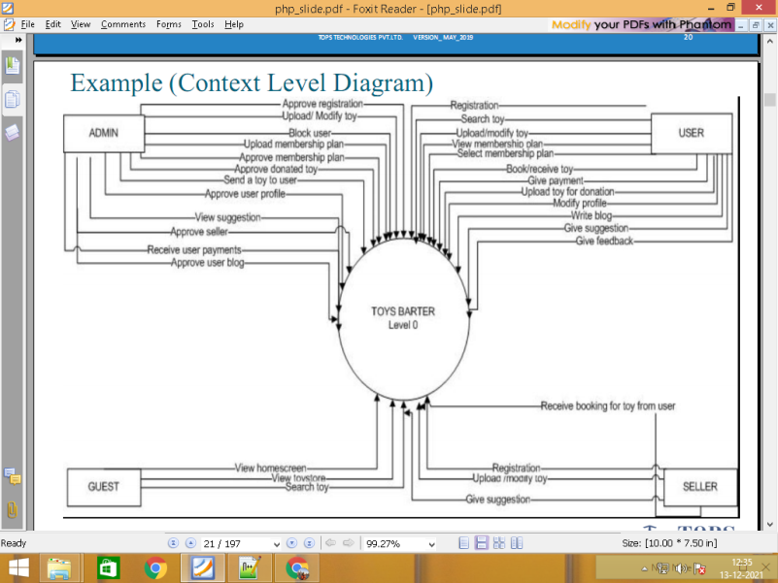

Level 1

\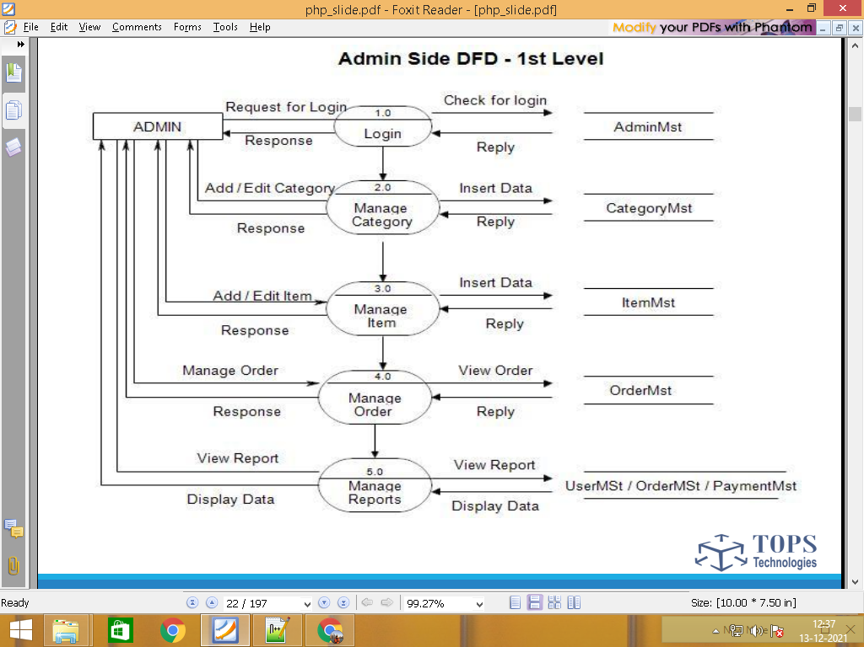

Search location vise Artist location.tbl

View Artist artist.tbl / service.tbl / album.tbl

Contact us contact.tbl

Customer Signup customer.tbl

Login customer.tbl

Manage profile customer.tbl

Contact Makeup Artist contact_artist.tbl

Logout customer.tbl

Login admin.tbl

Manage location location.tbl

Manage/view Makeup Artist artist.tbl / service.tbl / album.tbl

Admin Manage Contact us contact.tbl

Manage/View Customer customer.tbl

Manage Contact Makeup Artist contact_artist.tbl

Logout admin.tbl

Login artist.tbl

Manage profile artist.tbl

Manage service service.tbl

Makeup Artist Manage album album.tbl

Manage Customer Contact us contact_artist.tbl

Logout artist.tbl

Step 5: Define Total No. of Table List

admin.tbl

categories.tbl

products.tbl

contacts.tbl

customers.tbl

carts.tbl

orders.tbl

feedbacks.tbl

employees.tbl

Step 6 : Define Each table column / Data Dictionary

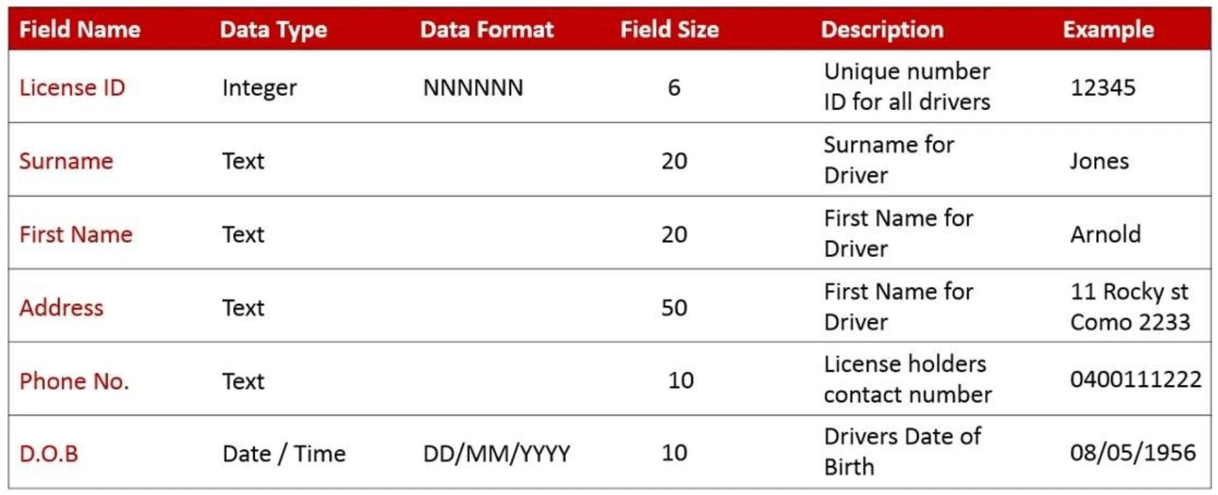

admin.tbl login 2 form

**id pk auto_increement**

name

email

password

**status**

categories.tbl

**id pk auto_increement**

name

image

subcategories form 3 / column 4

**id pk auto_increement**

cate_id fk

sub_catename

sub_cateimage

products.tbl

**id pk auto_increement**

cate_id fk

subcate_id fk

prod_name

short_desc

long_desc

main_price

disc_price

prod_image

**status**

contacts.tbl

**id pk auto_increement**

name

email

comment

customers.tbl signup form 5 / table column 7

**id pk auto_increement**

name

email

password

mobile

image

**status**

carts.tbl

**id pk auto_increement**

prod_id fk

cust_id fk

qty

total_price

orders.tbl

**id pk auto_increement**

cart_id fk

cust_id fk

total_amout

address

state

city

pincode

feedbacks.tbl

**id pk auto_increement**

order_id fk

cust_id fk

comment

employees.tbl

**id pk auto_increement**

name

email

password

**status**

**============================================================**

1. Designing

Database create / website designing

1. Implementation/coding

Data add / update / delete code

1. Testing

Website works without bugs or error

Testing

1. Maintenance

User guide

Installation

After maintenance service

Any changes & updating

================================================

Page layout ADMIN

Login.php

Dashboard

Add html form

Manage table page